TFE4141 Design of Digital Systems 1
Assignment 3: Vivado Tutorial with Simulation and Synthesis

Task 1: Go through the Tutorial
This tutorial is meant to guide you through the design flows of the Vivado Design Suite and get you familiarized with the workspace.
- Go through Lab 2 of the tutorial attached to this exercise.
- Answer the questions in Task 2 when you have completed the tutorial.

Task 2: Questions from the Tutorial
- How many flip-flops are used in the design? The design uses 1338 Flip Flops.
- How many LUTs are used in the design? The design uses 1631 LUTs.
- What is a LUT? A LUT (LookUp Table) is a component that determines what the output is for any given inputs. In the context of combinational logic, it is the truth table. In other words, a LUT behaves as any desired logic gates combination to output a signal.
- What is the total on-chip power? Total on-chip power is the power consumed internally within the FPGA, equal to the sum of: device power (to make the FPGA work, so static power) and design power (to make the user design work [I/Os, FF, logic gates used...], so dynamic power).
- Mention one thing you can explore in the flowing steps of the design flow:
- Simulation → The status of every input, output (or intermediate connection) in a specific time.
- Synthesis → The number of LUTs and FFs created from the VHDL code (basically RTL functions) designed by the user.
- Implementation → The location of the previous LUTs and FFs with the FPGA as well as the connections among them (routing).

Task 3: Simulation of Testbench and Component from Assignment 2
- Start a new project in Vivado.
- Make a new source file and type in the VHDL code you wrote under task 2 point 3 in assignment 2.
- Simulate the design and check if it behaves as expected. Extend the testbench with additional stimuli as needed.
The following picture shows the behavior of the VHDL designed in assignment 2, matching the results shown in its corresponding timing program:
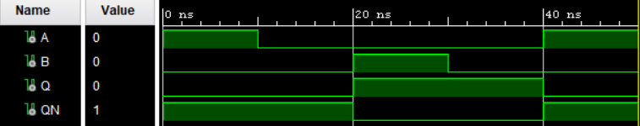

As a minor comment, Vivado requested us to change the type of outputs Q and QN from “out” to “inout” as they are being used as both input and output at the same time (highlighted in blue).
With the same structure as defined in the assignment 2, the testbench has been extended in the following way (highlighted in red):
LIBRARY ieee;  USE ieee.std_logic_1164.ALL;  ENTITY tb_assign3 IS  END tb_assign3;  ARCHITECTURE Behavioral OF tb_assign3 IS  COMPONENT Assig3  PORT(  A: IN std_logic;  B: IN std_logic;  Q: INOUT std_logic;  QN: INOUT std_logic);  END COMPONENT;  SIGNAL A : std_logic;  SIGNAL B : std_logic;  SIGNAL Q : std_logic;  SIGNAL QN : std_logic;  BEGIN  uut: Assig3 PORT MAP(  A => A,  B => B,  Q => Q,  QN => QN);  tb : PROCESS  BEGIN  A <= '1'; B <= '0';  wait for 10 ns;  A <= '0'; B <= '0';  wait for 10 ns;  A <= '0'; B <= '1';  wait for 10 ns;  A <= '0'; B <= '0';  wait for 10 ns;  B <= '1'; A <= '1';  wait for 10 ns;  B <= '0'; A <= '0';  wait for 10 ns;  END PROCESS;  END; | library IEEE;  use IEEE.STD_LOGIC_1164.ALL;  entity Assig3 is  port (  A, B: in std_logic;  Q, QN: inout std_logic  );  end entity Assig3;  architecture Behavioral of Assig3 is  begin  Q <= A nor QN;  QN <= B nor Q;  end architecture Behavioral;

With this new stimuli, as a final result we have found an oscillation in the very last step. This is because we got a particular situation, not seen so far: all inputs and outputs are 0 at a time.
This run-time error stops the simulation from 50ns on (where the conflict appears).

